**Work Plan**

**Anthony Walker**

**October 2023**

Here is a description of the aims to be covered for the MSc project. Fig. 1 shows the timeline and the steps to be cover until the project competition.

* Introduction
  + - Development of project background and aims
    - Context and discussion of existing tools
* Exploratory Analysis of Open Data
  + - Exploration of available open APIs/data sources
      * Python friendly HTTPS based APIs or other database integrations required?
    - Geospatial analysis of data sources to ensure sufficient coverage.
    - Transformation of data required?
    - Summary statistics of underlying datasets – building heights/topography/road lengths/air quality data.
* Web Framework Development
  + - Exploration of Webapp framework suitability
    - Develop initial webapp prototype.
      * Design/Sketch expected user interface.
      * Code and implement webapp
* Methods and Functions Development
  + - Outline expected webapp functionality
      * Data integration methods
      * Data transformation methods
      * Data modelling methods
* Model Development and Validation Testing
  + - Explore and implement statistical/machine learning models based on webapp transformed output data.
    - Compare model outputs to real world air quality monitoring data.
* User Testing
  + - Implement user testing phase
* Deployment
  + - Describe and manage app deployment and Continuous Integration plan.

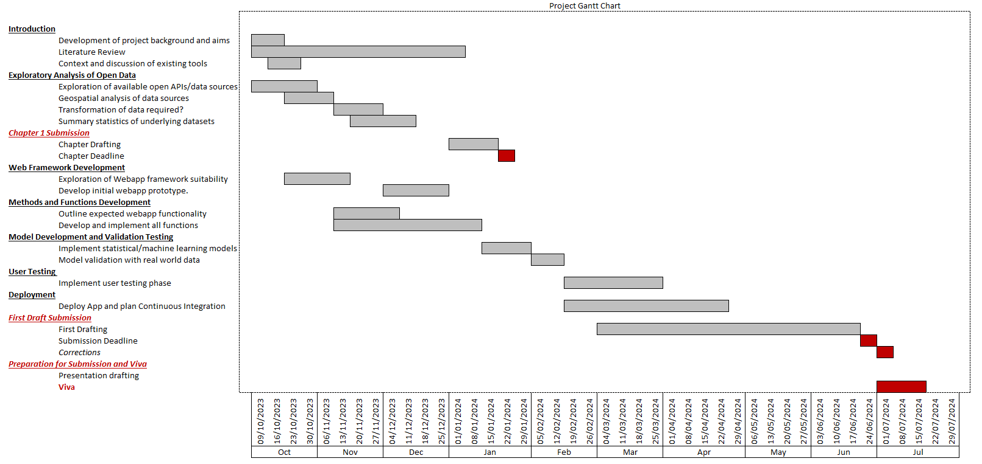Project Gantt Chart